**Assignment – 1**

**Question: 1 (SAKILA)  
**

1. **Screen Shot for MySQL Installation Complete**



1. **Query**

**SELECT c.last_name AS 'Last Name ', c.first_name AS 'First Name', COUNT(r.inventory_id) AS 'Total Film Rentals'**

**FROM customer c**

**INNER JOIN rental r ON c.customer_id = r.customer_id**

**INNER JOIN payment p ON p.rental_id = r.rental_id**

**AND p.customer_id = c.customer_id**

**INNER JOIN inventory i ON i.inventory_id = r.inventory_id**

**INNER JOIN film f ON f.film_id = i.film_id**

**GROUP BY c.first_name,c.last_name**

**ORDER BY count(r.inventory_id)**

**LIMIT 10;**

1. **Screen Shot**

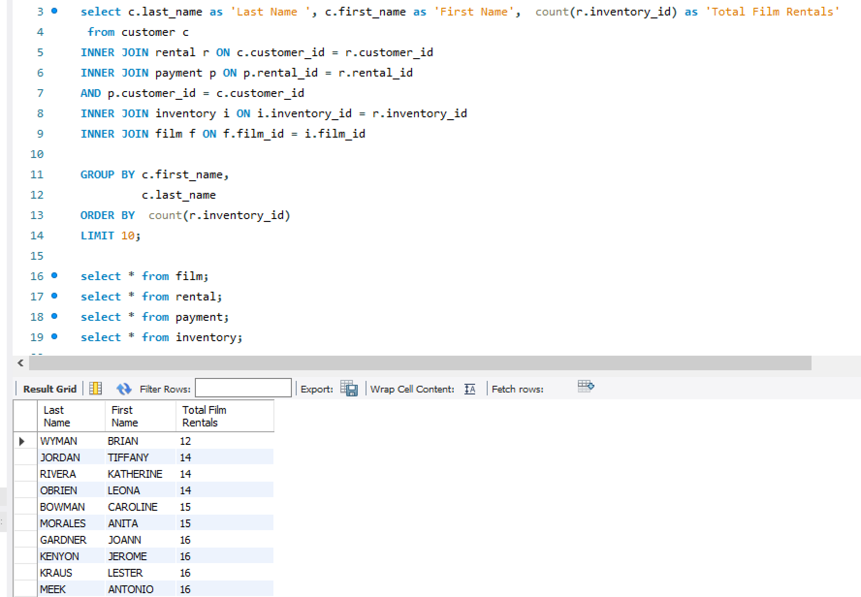

**Question 2 : (CHINOOK)**

1. **Query :**
2. **Screen shot:**